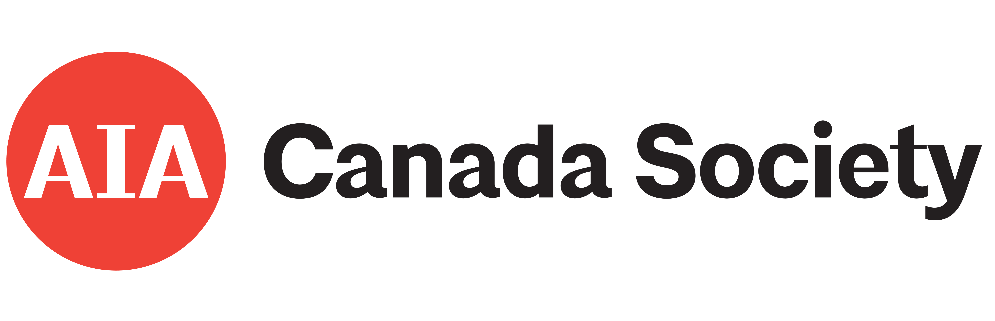 | 2026 AIA Canada Design Awards  Part A — Submission & Identification

Admin Only — Confidential
This form is for administrative use only and will NOT be shared with the jury.
Complete all required fields marked *. Submission deadline: October 31, 2026 (3:00 PM EST).
Entry fee applies — see Award Guidelines. Submit via email or the website portal.

Section 1 — Submission Overview

Project ID (admin only)
Project Name (Official) *
Entry Category *
Submission Date *

Section 2 — Submitting Firm & Contact

Name of Firm *
Submitter First Name *
Submitter Last Name *
Phone *
Mailing Address *
Email *
AIA Member Name (if different from submitter) *
AIA Member # *

Section 3 — Additional Firms

Complete if this is a joint venture or associated-architect submission. Add additional pages as required.
Architecture Firm #2

Firm Name
Contact Person — Full Name
Contact Person — Email

☐ Add another firm? — Yes, additional page attached

Section 4 — Architectural Credits

List all firms and collaborators to be credited for public display should this project receive recognition. Format: Type of Service: Firm Name (e.g., Associate Architect: Firm Name; Engineer – Structural: Firm Name; Landscape Architect: Firm Name).
Credits for Publication

Section 5 — Client / Owner Information

Client Name / Owner Name
Address

Confidentiality *
☐ No — the client/owner information may be used
☐ Yes — the client/owner information is Confidential — Not for Publication
Client Authorization

A separate email may be sent to the client to confirm approval for this project's entry into the AIA Canada Design Awards

Section 6 — Copyright & Permissions

By submitting to the AIA Canada Design Awards, you confirm the following. Please read carefully — this protects both you and the integrity of the awards program.
You confirm that:
— You are the author of the work, or have obtained all necessary permissions to submit it
— The work does not infringe on any third-party copyright
— You grant AIA Canada Society a non-exclusive license to use your submission for awards program promotion, educational and professional initiatives, and publication across digital and print platforms
Your work remains your intellectual property at all times. All use of submitted work will include appropriate credit to the author.

Greater Rights Declaration *
☐ Entrant has NOT secured greater rights to copyrighted material and understands that this submission must cease until such rights are obtained
☐ Entrant has secured greater rights to copyrighted material
Copyrighted Material Disclosure (if applicable)

List any third-party copyrighted material included in your submission (e.g., text, brochures, drawings, photographs, graphics, plans) and confirm that permission has been obtained. If not applicable, write “None.”
Copyrighted Work

Section 7 — Declarations & Signatures

7a — Terms & Conditions
☐ I agree to the Terms & Conditions
☐ I certify I hold rights to submit and grant reproduction rights to AIA Canada Society
☐ I confirm the information in Part A is accurate and complete
7b — Submitter Signature
Typed Full Legal Name *
Signature Date *

7c — Firm Approval
Your Firm Name *
Signature / Name *
Date *

Questions? rommy@aiacanadasociety.org | Submit via website portal or email.

